**Commodore Keyboard Tester Rev. 1**

**Testing**

# Test Setup

The test setup consisted of:

* A prototype of the keyboard tester rev. 1
* A multimeter (eevBlog 128GW)
* 2 4mm lab cables
* A working keyboard of the following computers:   
  C64  
  VIC-20  
  CBM3016 graphic keyboard  
  CBM8032 business keyboard  
  C16  
  C128  
  C128D  
  SX-64

The multimeter was set to Ohms, range 5kΩ.

# Test Execution

## C64

After connecting the keyboard, the meter showed OFL, which means “overflow” = the resistance is bigger than the range (open circuit).

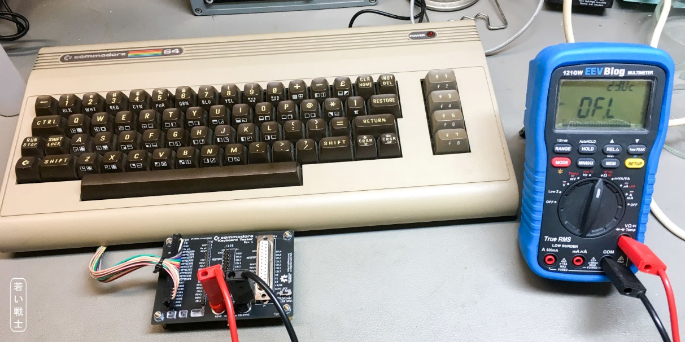

Figure 1: Testing the C64 keyboard

Every key produced a reading which was within the range.

## VIC-20

After connecting the keyboard, the meter showed OFL.

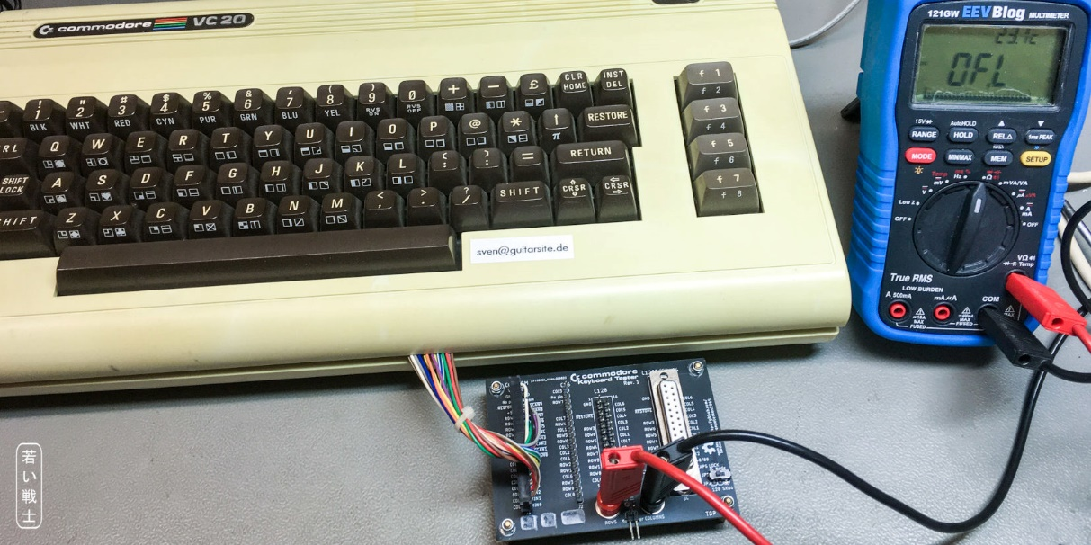

Figure 2: Testing the VIC-20 keyboard

Every key produced a reading which was within the range.

## CBM3016 graphic keyboard

After connecting the keyboard, the meter showed OFL.

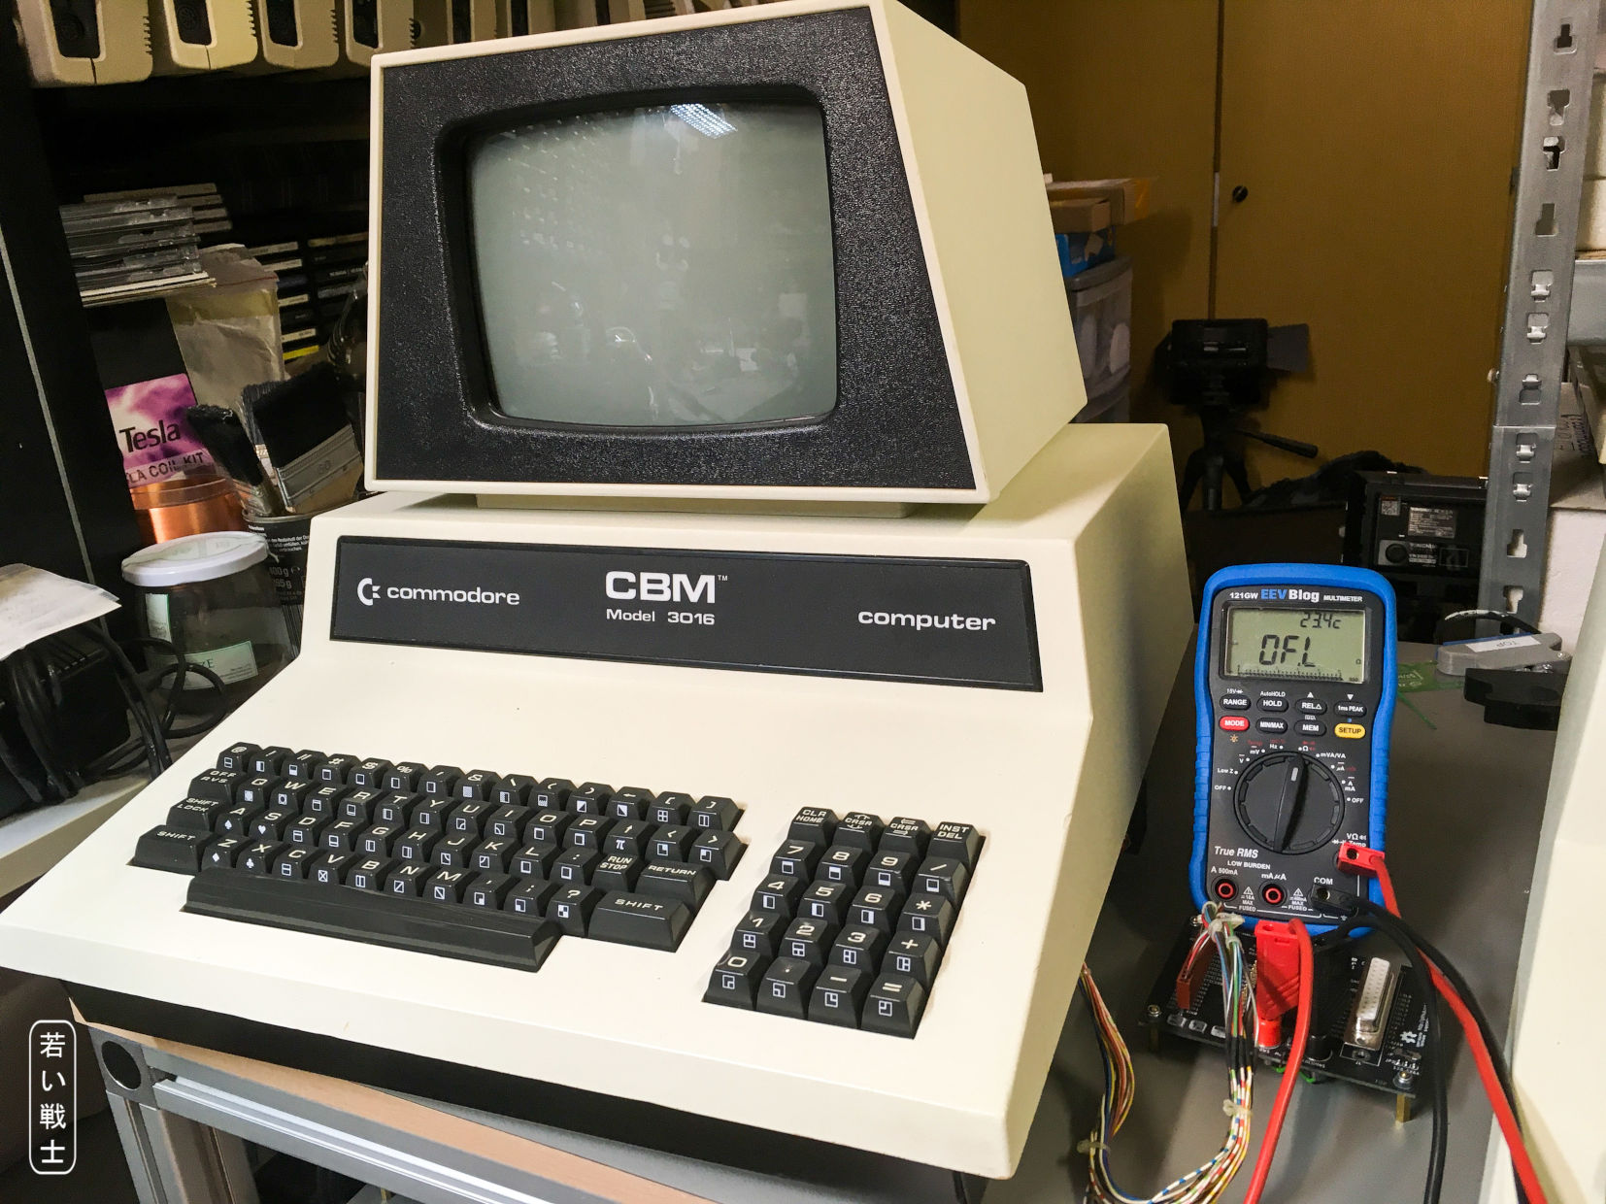

Figure 3: Testing the CBM3016 keyboard

Every key produced a reading which was within the range.

## CBM8032 business keyboard

After connecting the keyboard, the meter showed OFL.

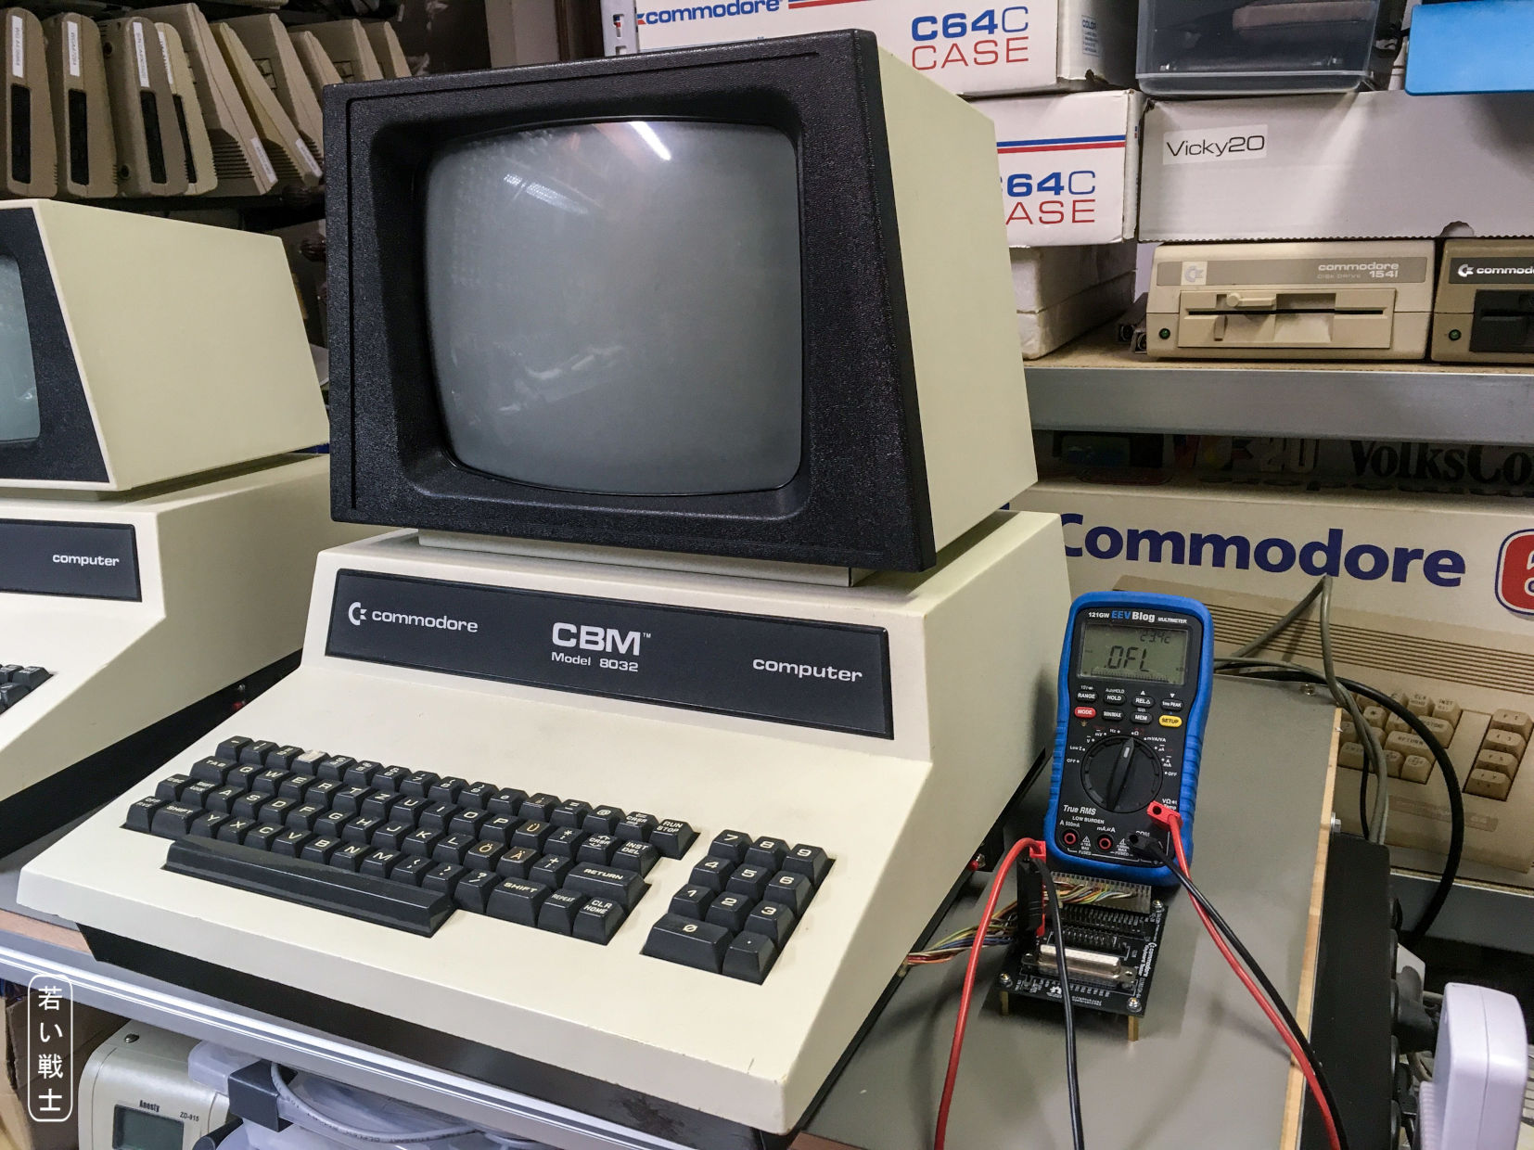

Figure 4: Testing the CBM8032 keyboard

Every key produced a reading which was within the range.

## C16

After connecting the keyboard, the meter showed OFL.

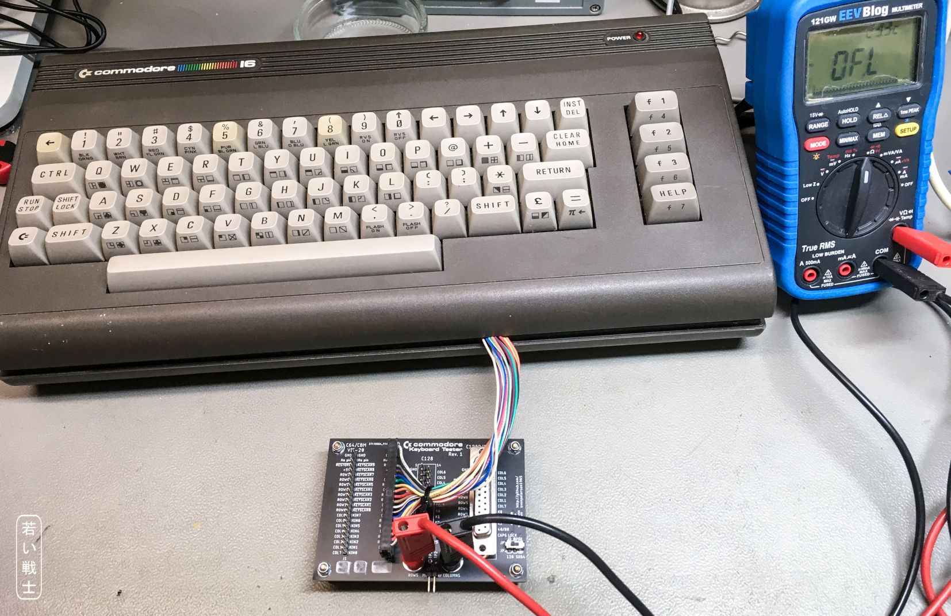

Figure 5: Testing the C16 keyboard

Every key produced a reading which was within the range.

## C128

After connecting the keyboard, the meter showed OFL.

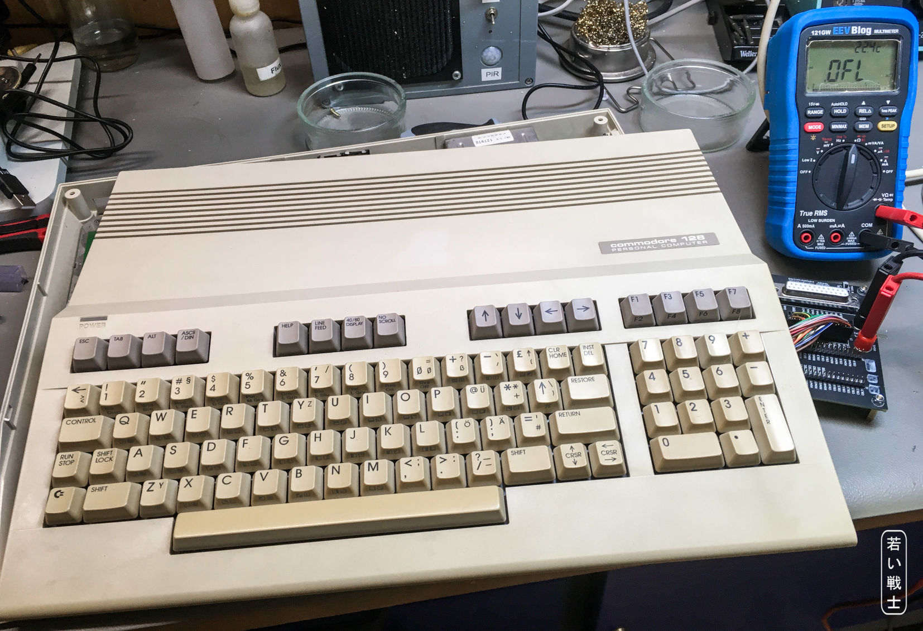

Figure 6: Testing the C128 keyboard

Every key produced a reading which was within the range.

## C128D

After connecting the keyboard, the meter showed OFL.

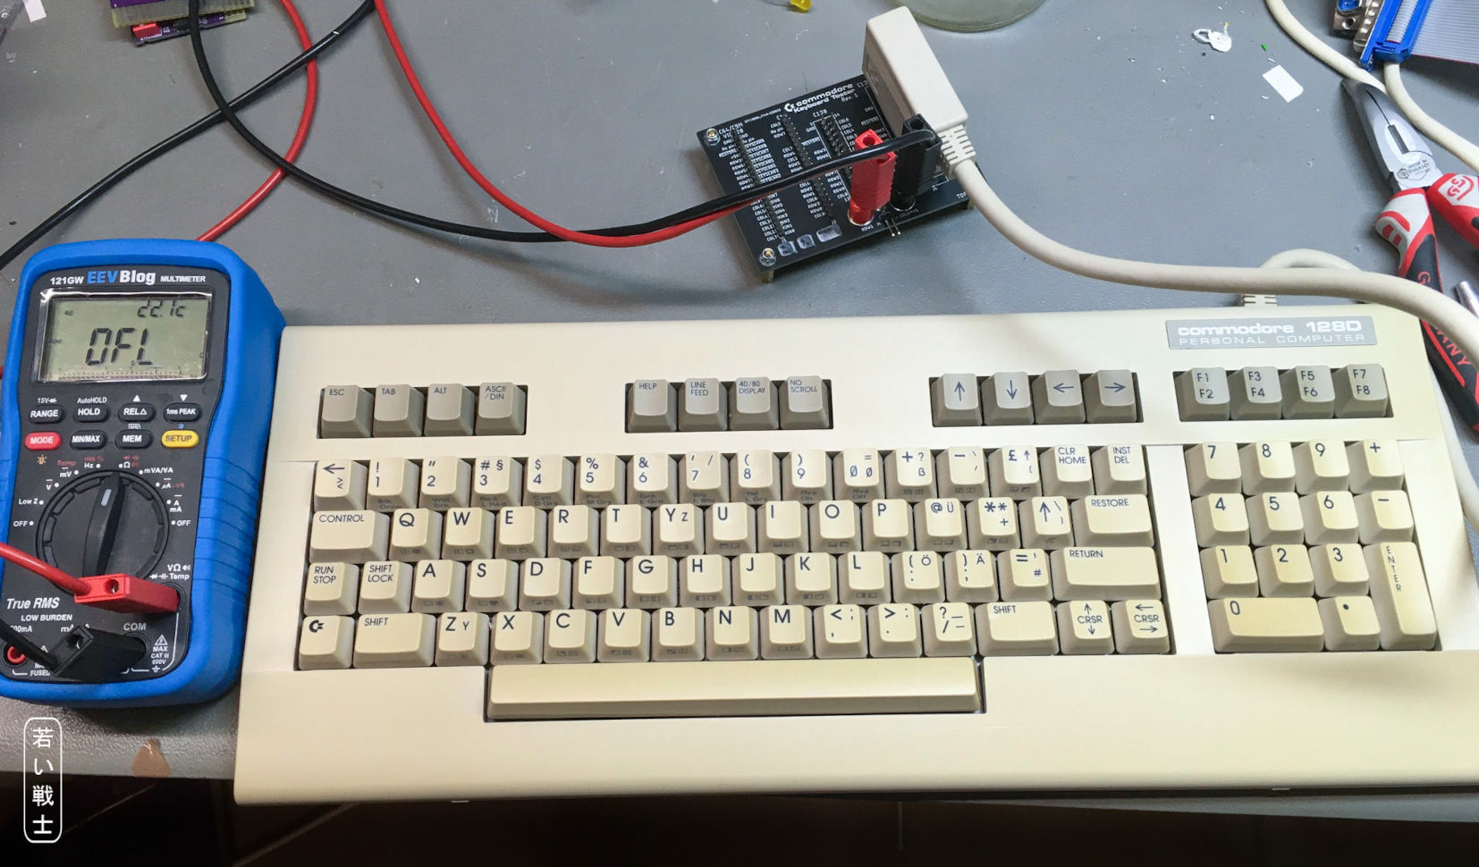

Figure 7: Testing the C128D keyboard

Every key produced a reading which was within the range.

## SX-64

This required the ribbon cable (Drawing No. 188-3-01-01).

After connecting the keyboard, the meter showed OFL.

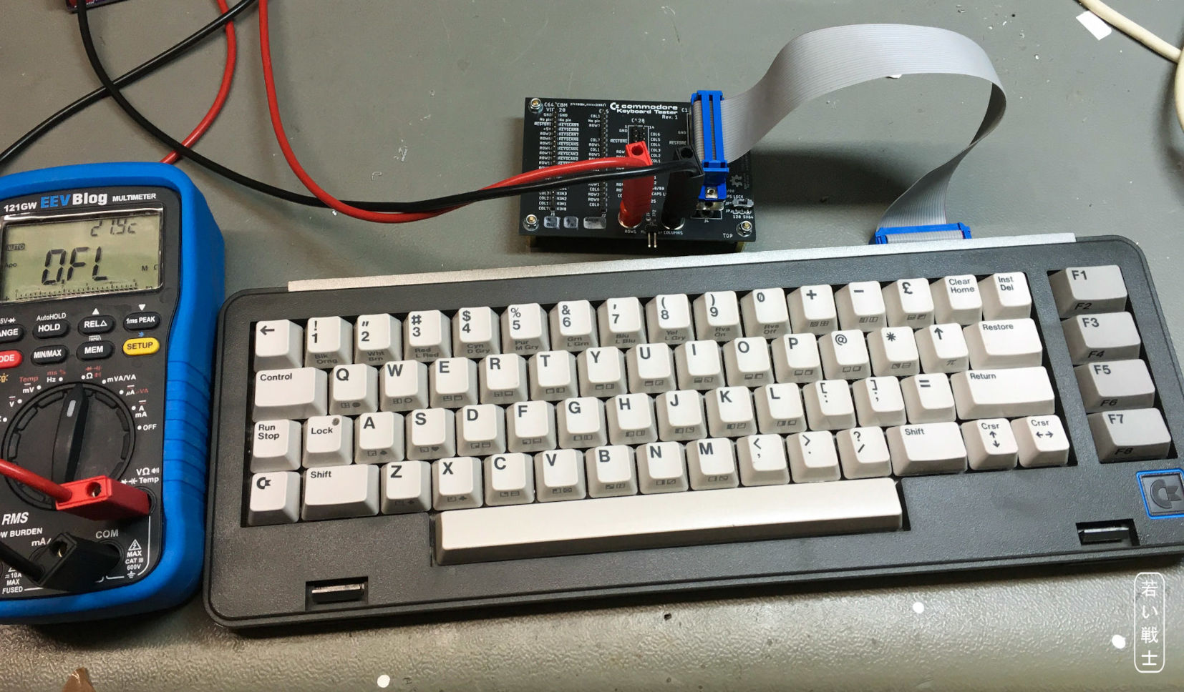

Figure 8: Testing the SX-64 keyboard

Every key produced a reading which was within the range.

# Conclusion

The Commodore Keyboard Tester Rev. 1 is fully functional.

(Note: Rev. 0 was functional, except the SX-64 keyboard)